**AMERICAN INTERNATIONAL UNIVERSITY–BANGLADESH (AIUB)**

**FACULTY OF SCIENCE & TECHNOLOGY**

**DEPARTMENT OF MATHEMATICS**

**COMPUTATIONAL STATISTICS AND PROBABILITY**

**Summer 2023-2024**

**Section: C, Group: Data Crew**

**PROJECT TITLE**

# **The Study of Climate Change Using Statistical Analysis**

**Course Teacher**

**Samira Salam**

**Group Member:**

|  |  |
| --- | --- |
| **Name** | **ID** |
| **1. SUMAIYA AFRIN** | **22-46304-1** |
| **2. S.M. RASEL** | **22-48039-2** |
| **3. MD.ABRAR RAFID SHAHRIAR** | **22-48055-2** |
| **4. MD.TANJIL TASHRIK ZIM** | **22-48021-2** |
| **5.MD.AL-IMRAN SAYEM** | **22-48023-2** |
| **6.KAOWSHIK MALAKER EMON** | **20-44045-2** |
| **7.Eshtab rak mahmud** | **21-45387-3** |
| **8. Nazmus Sakib** | **21-45391-3** |

Date of Submission: **24 September 2024**

**Introduction**

The temperature trends from January to August offer valuable insights into seasonal changes and climate patterns. This analysis examines temperature data across these months using various visualization tools such as bar graphs, histograms, pie charts, and correlation metrics. we have taken 200+ secondary data of these months from [Weather in January 2024 in Dhaka, Bangladesh (timeanddate.com)](https://www.timeanddate.com/weather/bangladesh/dhaka/historic?month=1&year=2024) . The bar graph will showcase monthly average temperatures, while the histogram provides a frequency distribution of temperature ranges. A pie chart breaks down temperature proportions within certain thresholds, and a correlation analysis assesses the relationship between temperature and dates. Together, these visualizations help us better understand weather variations over time and identify potential patterns that might impact sectors like agriculture, energy, and tourism.

**Data Table:**

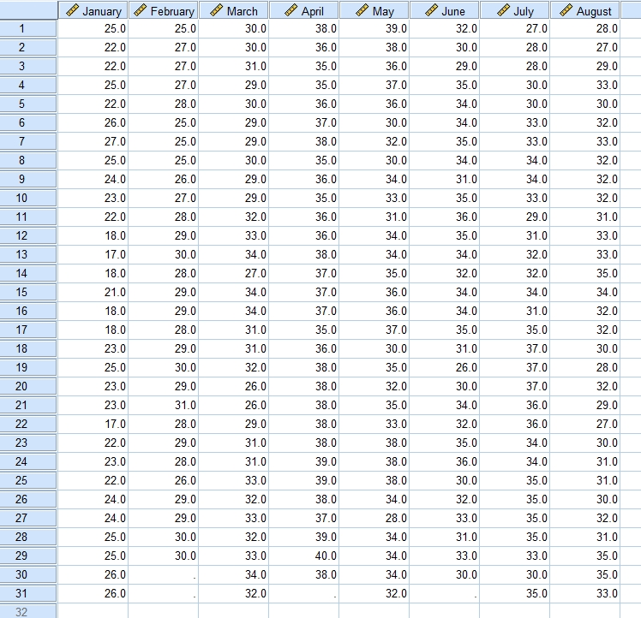

**Bar Chat**

FREQUENCIES VARIABLES=January February March April May June July August

/STATISTICS=STDDEV VARIANCE RANGE MINIMUM MAXIMUM SEMEAN MEAN MEDIAN MODE

/BARCHART FREQ

/ORDER=ANALYSIS

|  |  |  |  |  |  |  |
| --- | --- | --- | --- | --- | --- | --- |
| **Statistics** | | | | | | |
|  | | Temperature on January | Temperature on February | Temperature on March | Temperature on April | Temperature on May |
| N | Valid | 31 | 29 | 31 | 30 | 31 |
| Missing | 0 | 2 | 0 | 1 | 0 |
| Mean | | 22.613 | 27.966 | 30.839 | 37.100 | 34.290 |
| Std. Error of Mean | | .5157 | .3158 | .4019 | .2553 | .4977 |
| Median | | 23.000 | 28.000 | 31.000 | 37.000 | 34.000 |
| Mode | | 22.0a | 29.0 | 29.0 | 38.0 | 34.0 |
| Std. Deviation | | 2.8714 | 1.7005 | 2.2375 | 1.3983 | 2.7712 |
| Variance | | 8.245 | 2.892 | 5.006 | 1.955 | 7.680 |
| Range | | 10.0 | 6.0 | 8.0 | 5.0 | 11.0 |
| Minimum | | 17.0 | 25.0 | 26.0 | 35.0 | 28.0 |
| Maximum | | 27.0 | 31.0 | 34.0 | 40.0 | 39.0 |

|  |  |  |  |  |
| --- | --- | --- | --- | --- |
| **Statistics** | | | | |
|  | | Temperature on June | Temperature on July | Temperature on August |
| N | Valid | 30 | 31 | 31 |
| Missing | 1 | 0 | 0 |
| Mean | | 32.733 | 33.000 | 31.355 |
| Std. Error of Mean | | .4340 | .5016 | .3923 |
| Median | | 33.500 | 34.000 | 32.000 |
| Mode | | 34.0 | 35.0 | 32.0 |
| Std. Deviation | | 2.3771 | 2.7928 | 2.1840 |
| Variance | | 5.651 | 7.800 | 4.770 |
| Range | | 10.0 | 10.0 | 8.0 |
| Minimum | | 26.0 | 27.0 | 27.0 |
| Maximum | | 36.0 | 37.0 | 35.0 |

|  |
| --- |
| a. Multiple modes exist. The smallest value is shown |

**Frequency Table**

|  |  |  |  |  |  |
| --- | --- | --- | --- | --- | --- |
| **Temperature on January** | | | | | |
|  | | Frequency | Percent | Valid Percent | Cumulative Percent |
| Valid | 17.0 | 2 | 6.5 | 6.5 | 6.5 |
| 18.0 | 4 | 12.9 | 12.9 | 19.4 |
| 21.0 | 1 | 3.2 | 3.2 | 22.6 |
| 22.0 | 6 | 19.4 | 19.4 | 41.9 |
| 23.0 | 5 | 16.1 | 16.1 | 58.1 |
| 24.0 | 3 | 9.7 | 9.7 | 67.7 |
| 25.0 | 6 | 19.4 | 19.4 | 87.1 |
| 26.0 | 3 | 9.7 | 9.7 | 96.8 |
| 27.0 | 1 | 3.2 | 3.2 | 100.0 |
| Total | 31 | 100.0 | 100.0 |  |

|  |  |  |  |  |  |
| --- | --- | --- | --- | --- | --- |
| **Temperature on February** | | | | | |
|  | | Frequency | Percent | Valid Percent | Cumulative Percent |
| Valid | 25.0 | 4 | 12.9 | 13.8 | 13.8 |
| 26.0 | 2 | 6.5 | 6.9 | 20.7 |
| 27.0 | 4 | 12.9 | 13.8 | 34.5 |
| 28.0 | 6 | 19.4 | 20.7 | 55.2 |
| 29.0 | 8 | 25.8 | 27.6 | 82.8 |
| 30.0 | 4 | 12.9 | 13.8 | 96.6 |
| 31.0 | 1 | 3.2 | 3.4 | 100.0 |
| Total | 29 | 93.5 | 100.0 |  |
| Missing | System | 2 | 6.5 |  |  |
| Total | | 31 | 100.0 |  |  |

|  |  |  |  |  |  |
| --- | --- | --- | --- | --- | --- |
| **Temperature on March** | | | | | |
|  | | Frequency | Percent | Valid Percent | Cumulative Percent |
| Valid | 26.0 | 2 | 6.5 | 6.5 | 6.5 |
| 27.0 | 1 | 3.2 | 3.2 | 9.7 |
| 29.0 | 6 | 19.4 | 19.4 | 29.0 |
| 30.0 | 4 | 12.9 | 12.9 | 41.9 |
| 31.0 | 5 | 16.1 | 16.1 | 58.1 |
| 32.0 | 5 | 16.1 | 16.1 | 74.2 |
| 33.0 | 4 | 12.9 | 12.9 | 87.1 |
| 34.0 | 4 | 12.9 | 12.9 | 100.0 |
| Total | 31 | 100.0 | 100.0 |  |

|  |  |  |  |  |  |
| --- | --- | --- | --- | --- | --- |
| **Temperature on April** | | | | | |
|  | | Frequency | Percent | Valid Percent | Cumulative Percent |
| Valid | 35.0 | 5 | 16.1 | 16.7 | 16.7 |
| 36.0 | 6 | 19.4 | 20.0 | 36.7 |
| 37.0 | 5 | 16.1 | 16.7 | 53.3 |
| 38.0 | 10 | 32.3 | 33.3 | 86.7 |
| 39.0 | 3 | 9.7 | 10.0 | 96.7 |
| 40.0 | 1 | 3.2 | 3.3 | 100.0 |
| Total | 30 | 96.8 | 100.0 |  |
| Missing | System | 1 | 3.2 |  |  |
| Total | | 31 | 100.0 |  |  |

|  |  |  |  |  |  |
| --- | --- | --- | --- | --- | --- |
| **Temperature on May** | | | | | |
|  | | Frequency | Percent | Valid Percent | Cumulative Percent |
| Valid | 28.0 | 1 | 3.2 | 3.2 | 3.2 |
| 30.0 | 3 | 9.7 | 9.7 | 12.9 |
| 31.0 | 1 | 3.2 | 3.2 | 16.1 |
| 32.0 | 3 | 9.7 | 9.7 | 25.8 |
| 33.0 | 2 | 6.5 | 6.5 | 32.3 |
| 34.0 | 7 | 22.6 | 22.6 | 54.8 |
| 35.0 | 3 | 9.7 | 9.7 | 64.5 |
| 36.0 | 4 | 12.9 | 12.9 | 77.4 |
| 37.0 | 2 | 6.5 | 6.5 | 83.9 |
| 38.0 | 4 | 12.9 | 12.9 | 96.8 |
| 39.0 | 1 | 3.2 | 3.2 | 100.0 |
| Total | 31 | 100.0 | 100.0 |  |

|  |  |  |  |  |  |
| --- | --- | --- | --- | --- | --- |
| **Temperature on June** | | | | | |
|  | | Frequency | Percent | Valid Percent | Cumulative Percent |
| Valid | 26.0 | 1 | 3.2 | 3.3 | 3.3 |
| 29.0 | 1 | 3.2 | 3.3 | 6.7 |
| 30.0 | 4 | 12.9 | 13.3 | 20.0 |
| 31.0 | 3 | 9.7 | 10.0 | 30.0 |
| 32.0 | 4 | 12.9 | 13.3 | 43.3 |
| 33.0 | 2 | 6.5 | 6.7 | 50.0 |
| 34.0 | 7 | 22.6 | 23.3 | 73.3 |
| 35.0 | 6 | 19.4 | 20.0 | 93.3 |
| 36.0 | 2 | 6.5 | 6.7 | 100.0 |
| Total | 30 | 96.8 | 100.0 |  |
| Missing | System | 1 | 3.2 |  |  |
| Total | | 31 | 100.0 |  |  |

|  |  |  |  |  |  |
| --- | --- | --- | --- | --- | --- |
| **Temperature on July** | | | | | |
|  | | Frequency | Percent | Valid Percent | Cumulative Percent |
| Valid | 27.0 | 1 | 3.2 | 3.2 | 3.2 |
| 28.0 | 2 | 6.5 | 6.5 | 9.7 |
| 29.0 | 1 | 3.2 | 3.2 | 12.9 |
| 30.0 | 3 | 9.7 | 9.7 | 22.6 |
| 31.0 | 2 | 6.5 | 6.5 | 29.0 |
| 32.0 | 2 | 6.5 | 6.5 | 35.5 |
| 33.0 | 4 | 12.9 | 12.9 | 48.4 |
| 34.0 | 5 | 16.1 | 16.1 | 64.5 |
| 35.0 | 6 | 19.4 | 19.4 | 83.9 |
| 36.0 | 2 | 6.5 | 6.5 | 90.3 |
| 37.0 | 3 | 9.7 | 9.7 | 100.0 |
| Total | 31 | 100.0 | 100.0 |  |

|  |  |  |  |  |  |
| --- | --- | --- | --- | --- | --- |
| **Temperature on August** | | | | | |
|  | | Frequency | Percent | Valid Percent | Cumulative Percent |
| Valid | 27.0 | 2 | 6.5 | 6.5 | 6.5 |
| 28.0 | 2 | 6.5 | 6.5 | 12.9 |
| 29.0 | 2 | 6.5 | 6.5 | 19.4 |
| 30.0 | 4 | 12.9 | 12.9 | 32.3 |
| 31.0 | 4 | 12.9 | 12.9 | 45.2 |
| 32.0 | 8 | 25.8 | 25.8 | 71.0 |
| 33.0 | 5 | 16.1 | 16.1 | 87.1 |
| 34.0 | 1 | 3.2 | 3.2 | 90.3 |
| 35.0 | 3 | 9.7 | 9.7 | 100.0 |
| Total | 31 | 100.0 | 100.0 |  |

**Bar Chart**

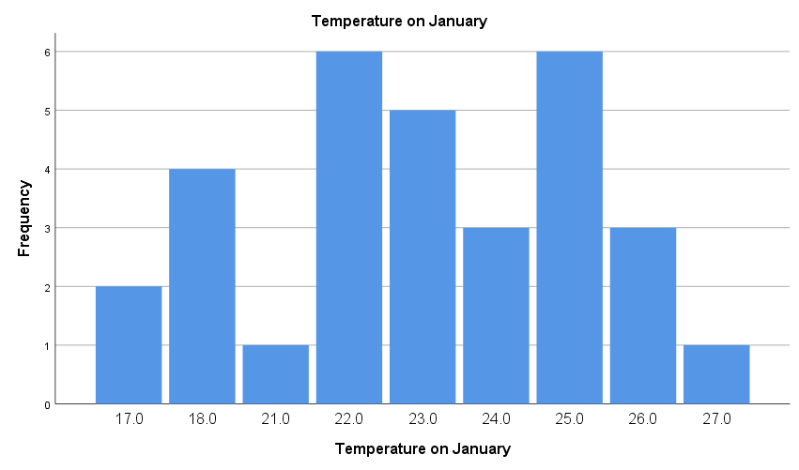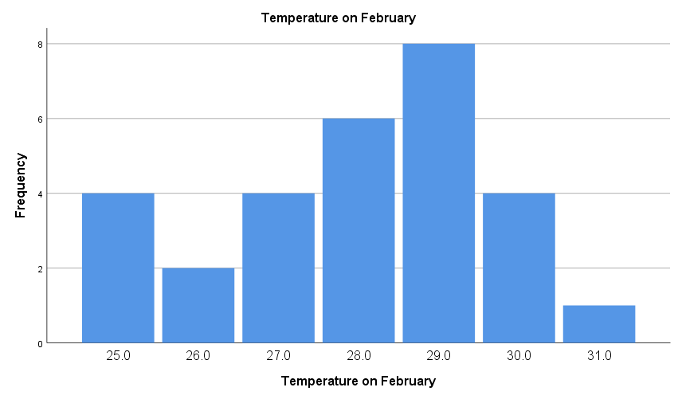

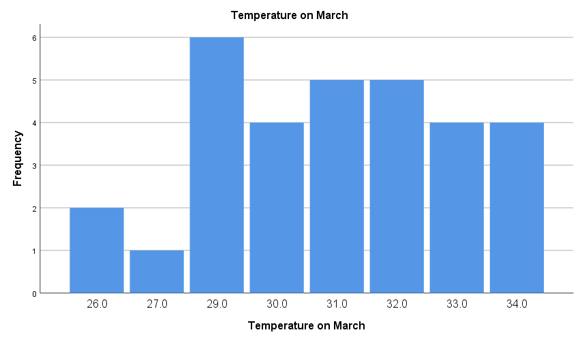

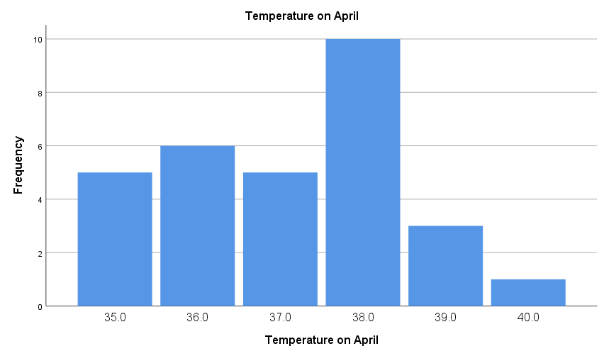

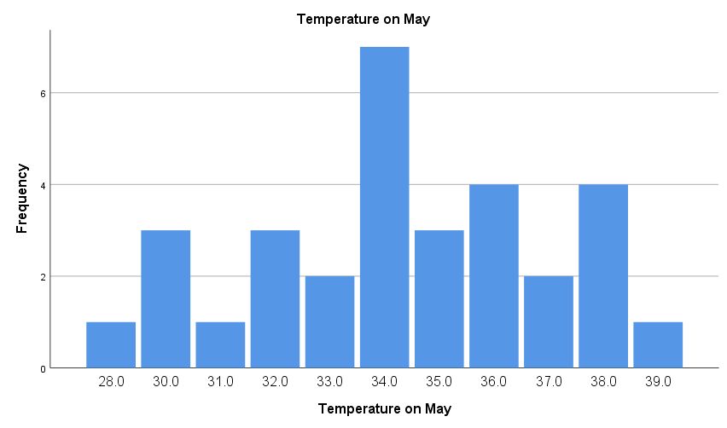

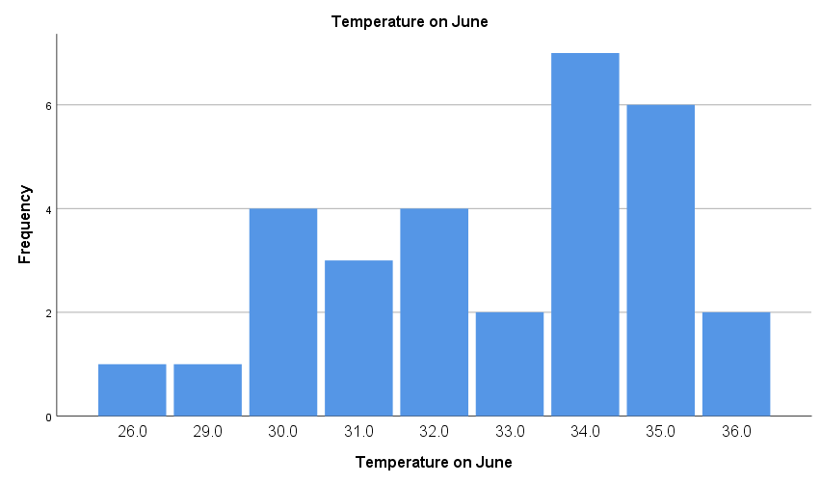

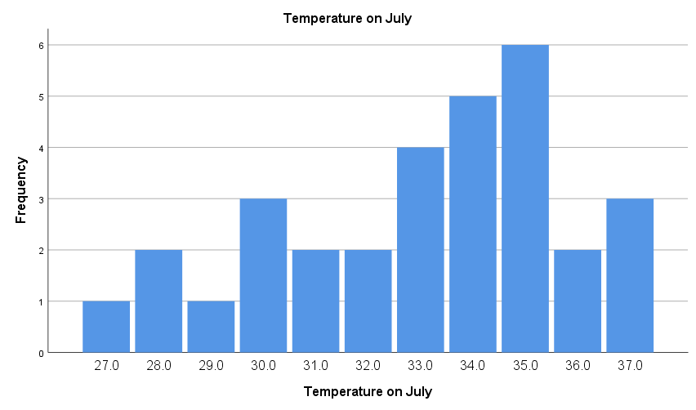

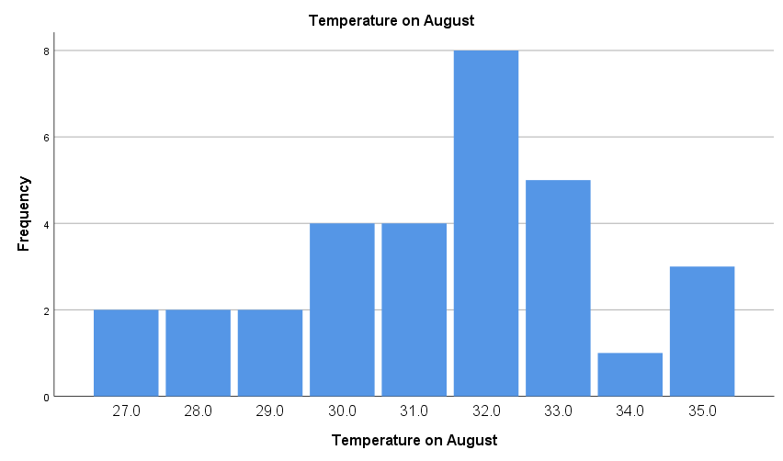

## **PIE Chart**

FREQUENCIES VARIABLES=January February March April May June July August

/STATISTICS=STDDEV VARIANCE RANGE MINIMUM MAXIMUM SEMEAN

/PIECHART FREQ

/ORDER=ANALYSIS.

|  |  |  |  |  |  |  |
| --- | --- | --- | --- | --- | --- | --- |
| **Statistics** | | | | | | |
|  | | Temperature on January | Temperature on February | Temperature on March | Temperature on April | Temperature on May |
| N | Valid | 31 | 29 | 31 | 30 | 31 |
| Missing | 0 | 2 | 0 | 1 | 0 |
| Std. Error of Mean | | .5157 | .3158 | .4019 | .2553 | .4977 |
| Std. Deviation | | 2.8714 | 1.7005 | 2.2375 | 1.3983 | 2.7712 |
| Variance | | 8.245 | 2.892 | 5.006 | 1.955 | 7.680 |
| Range | | 10.0 | 6.0 | 8.0 | 5.0 | 11.0 |
| Minimum | | 17.0 | 25.0 | 26.0 | 35.0 | 28.0 |
| Maximum | | 27.0 | 31.0 | 34.0 | 40.0 | 39.0 |

|  |  |  |  |  |
| --- | --- | --- | --- | --- |
| **Statistics** | | | | |
|  | | Temperature on June | Temperature on July | Temperature on August |
| N | Valid | 30 | 31 | 31 |
| Missing | 1 | 0 | 0 |
| Std. Error of Mean | | .4340 | .5016 | .3923 |
| Std. Deviation | | 2.3771 | 2.7928 | 2.1840 |
| Variance | | 5.651 | 7.800 | 4.770 |
| Range | | 10.0 | 10.0 | 8.0 |
| Minimum | | 26.0 | 27.0 | 27.0 |
| Maximum | | 36.0 | 37.0 | 35.0 |

**Frequency Table**

|  |  |  |  |  |  |
| --- | --- | --- | --- | --- | --- |
| **Temperature on January** | | | | | |
|  | | Frequency | Percent | Valid Percent | Cumulative Percent |
| Valid | 17.0 | 2 | 6.5 | 6.5 | 6.5 |
| 18.0 | 4 | 12.9 | 12.9 | 19.4 |
| 21.0 | 1 | 3.2 | 3.2 | 22.6 |
| 22.0 | 6 | 19.4 | 19.4 | 41.9 |
| 23.0 | 5 | 16.1 | 16.1 | 58.1 |
| 24.0 | 3 | 9.7 | 9.7 | 67.7 |
| 25.0 | 6 | 19.4 | 19.4 | 87.1 |
| 26.0 | 3 | 9.7 | 9.7 | 96.8 |
| 27.0 | 1 | 3.2 | 3.2 | 100.0 |
| Total | 31 | 100.0 | 100.0 |  |

|  |  |  |  |  |  |
| --- | --- | --- | --- | --- | --- |
| **Temperature on February** | | | | | |
|  | | Frequency | Percent | Valid Percent | Cumulative Percent |
| Valid | 25.0 | 4 | 12.9 | 13.8 | 13.8 |
| 26.0 | 2 | 6.5 | 6.9 | 20.7 |
| 27.0 | 4 | 12.9 | 13.8 | 34.5 |
| 28.0 | 6 | 19.4 | 20.7 | 55.2 |
| 29.0 | 8 | 25.8 | 27.6 | 82.8 |
| 30.0 | 4 | 12.9 | 13.8 | 96.6 |
| 31.0 | 1 | 3.2 | 3.4 | 100.0 |
| Total | 29 | 93.5 | 100.0 |  |
| Missing | System | 2 | 6.5 |  |  |
| Total | | 31 | 100.0 |  |  |

|  |  |  |  |  |  |
| --- | --- | --- | --- | --- | --- |
| **Temperature on March** | | | | | |
|  | | Frequency | Percent | Valid Percent | Cumulative Percent |
| Valid | 26.0 | 2 | 6.5 | 6.5 | 6.5 |
| 27.0 | 1 | 3.2 | 3.2 | 9.7 |
| 29.0 | 6 | 19.4 | 19.4 | 29.0 |
| 30.0 | 4 | 12.9 | 12.9 | 41.9 |
| 31.0 | 5 | 16.1 | 16.1 | 58.1 |
| 32.0 | 5 | 16.1 | 16.1 | 74.2 |
| 33.0 | 4 | 12.9 | 12.9 | 87.1 |
| 34.0 | 4 | 12.9 | 12.9 | 100.0 |
| Total | 31 | 100.0 | 100.0 |  |

|  |  |  |  |  |  |
| --- | --- | --- | --- | --- | --- |
| **Temperature on April** | | | | | |
|  | | Frequency | Percent | Valid Percent | Cumulative Percent |
| Valid | 35.0 | 5 | 16.1 | 16.7 | 16.7 |
| 36.0 | 6 | 19.4 | 20.0 | 36.7 |
| 37.0 | 5 | 16.1 | 16.7 | 53.3 |
| 38.0 | 10 | 32.3 | 33.3 | 86.7 |
| 39.0 | 3 | 9.7 | 10.0 | 96.7 |
| 40.0 | 1 | 3.2 | 3.3 | 100.0 |
| Total | 30 | 96.8 | 100.0 |  |
| Missing | System | 1 | 3.2 |  |  |
| Total | | 31 | 100.0 |  |  |

|  |  |  |  |  |  |
| --- | --- | --- | --- | --- | --- |
| **Temperature on May** | | | | | |
|  | | Frequency | Percent | Valid Percent | Cumulative Percent |
| Valid | 28.0 | 1 | 3.2 | 3.2 | 3.2 |
| 30.0 | 3 | 9.7 | 9.7 | 12.9 |
| 31.0 | 1 | 3.2 | 3.2 | 16.1 |
| 32.0 | 3 | 9.7 | 9.7 | 25.8 |
| 33.0 | 2 | 6.5 | 6.5 | 32.3 |
| 34.0 | 7 | 22.6 | 22.6 | 54.8 |
| 35.0 | 3 | 9.7 | 9.7 | 64.5 |
| 36.0 | 4 | 12.9 | 12.9 | 77.4 |
| 37.0 | 2 | 6.5 | 6.5 | 83.9 |
| 38.0 | 4 | 12.9 | 12.9 | 96.8 |
| 39.0 | 1 | 3.2 | 3.2 | 100.0 |
| Total | 31 | 100.0 | 100.0 |  |

|  |  |  |  |  |  |
| --- | --- | --- | --- | --- | --- |
| **Temperature on June** | | | | | |
|  | | Frequency | Percent | Valid Percent | Cumulative Percent |
| Valid | 26.0 | 1 | 3.2 | 3.3 | 3.3 |
| 29.0 | 1 | 3.2 | 3.3 | 6.7 |
| 30.0 | 4 | 12.9 | 13.3 | 20.0 |
| 31.0 | 3 | 9.7 | 10.0 | 30.0 |
| 32.0 | 4 | 12.9 | 13.3 | 43.3 |
| 33.0 | 2 | 6.5 | 6.7 | 50.0 |
| 34.0 | 7 | 22.6 | 23.3 | 73.3 |
| 35.0 | 6 | 19.4 | 20.0 | 93.3 |
| 36.0 | 2 | 6.5 | 6.7 | 100.0 |
| Total | 30 | 96.8 | 100.0 |  |
| Missing | System | 1 | 3.2 |  |  |
| Total | | 31 | 100.0 |  |  |

|  |  |  |  |  |  |
| --- | --- | --- | --- | --- | --- |
| **Temperature on July** | | | | | |
|  | | Frequency | Percent | Valid Percent | Cumulative Percent |
| Valid | 27.0 | 1 | 3.2 | 3.2 | 3.2 |
| 28.0 | 2 | 6.5 | 6.5 | 9.7 |
| 29.0 | 1 | 3.2 | 3.2 | 12.9 |
| 30.0 | 3 | 9.7 | 9.7 | 22.6 |
| 31.0 | 2 | 6.5 | 6.5 | 29.0 |
| 32.0 | 2 | 6.5 | 6.5 | 35.5 |
| 33.0 | 4 | 12.9 | 12.9 | 48.4 |
| 34.0 | 5 | 16.1 | 16.1 | 64.5 |
| 35.0 | 6 | 19.4 | 19.4 | 83.9 |
| 36.0 | 2 | 6.5 | 6.5 | 90.3 |
| 37.0 | 3 | 9.7 | 9.7 | 100.0 |
| Total | 31 | 100.0 | 100.0 |  |

|  |  |  |  |  |  |
| --- | --- | --- | --- | --- | --- |
| **Temperature on August** | | | | | |
|  | | Frequency | Percent | Valid Percent | Cumulative Percent |
| Valid | 27.0 | 2 | 6.5 | 6.5 | 6.5 |
| 28.0 | 2 | 6.5 | 6.5 | 12.9 |
| 29.0 | 2 | 6.5 | 6.5 | 19.4 |
| 30.0 | 4 | 12.9 | 12.9 | 32.3 |
| 31.0 | 4 | 12.9 | 12.9 | 45.2 |
| 32.0 | 8 | 25.8 | 25.8 | 71.0 |
| 33.0 | 5 | 16.1 | 16.1 | 87.1 |
| 34.0 | 1 | 3.2 | 3.2 | 90.3 |
| 35.0 | 3 | 9.7 | 9.7 | 100.0 |
| Total | 31 | 100.0 | 100.0 |  |

**Pie Chart**

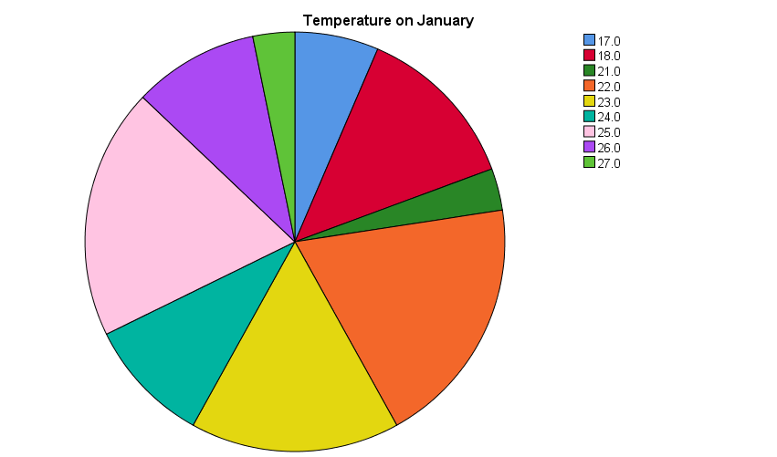

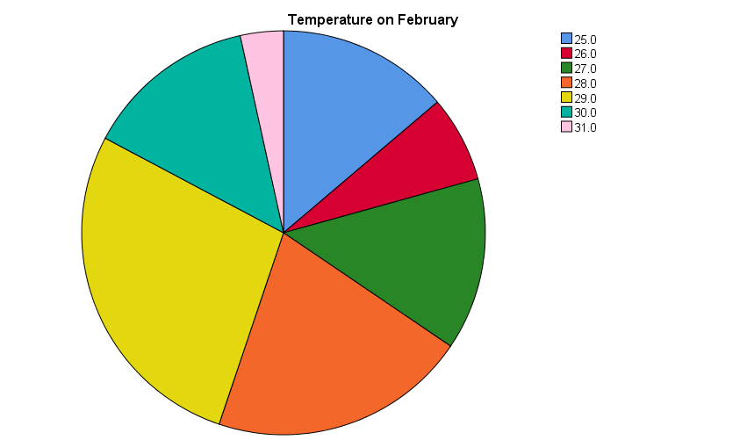

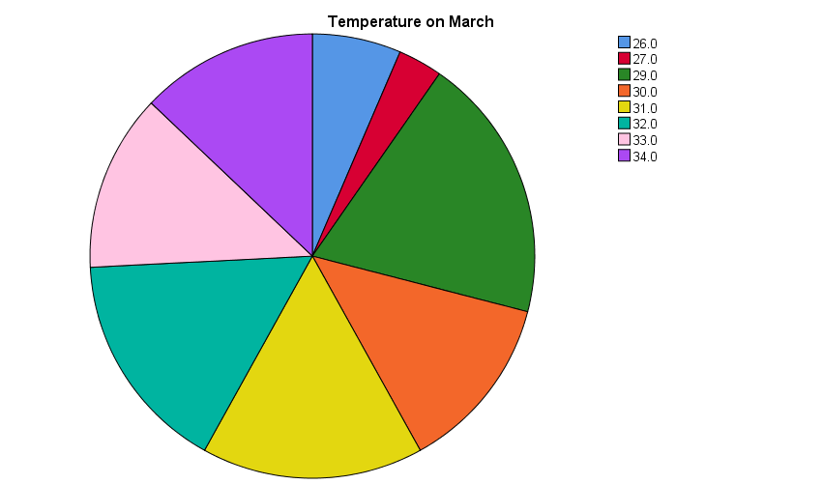

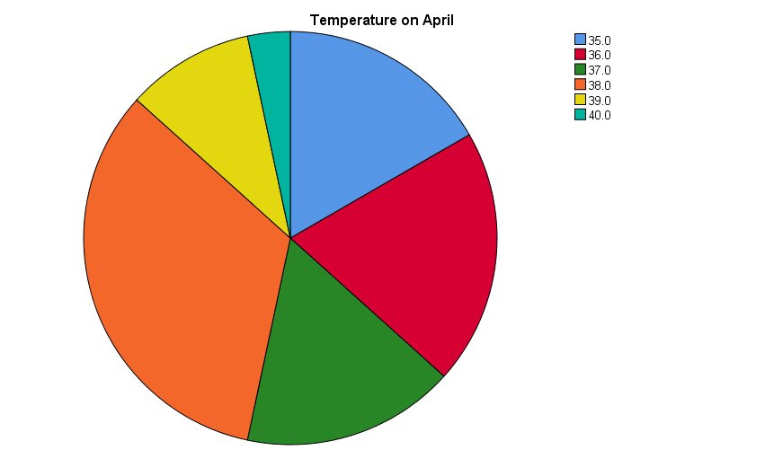

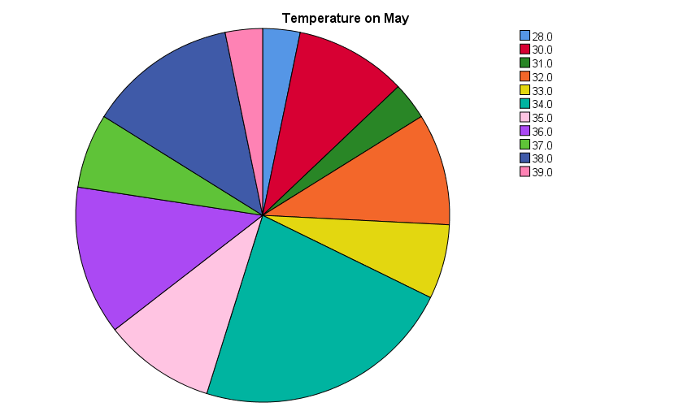

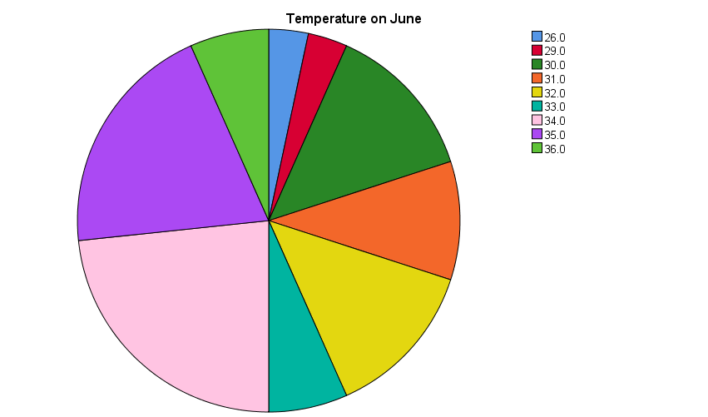

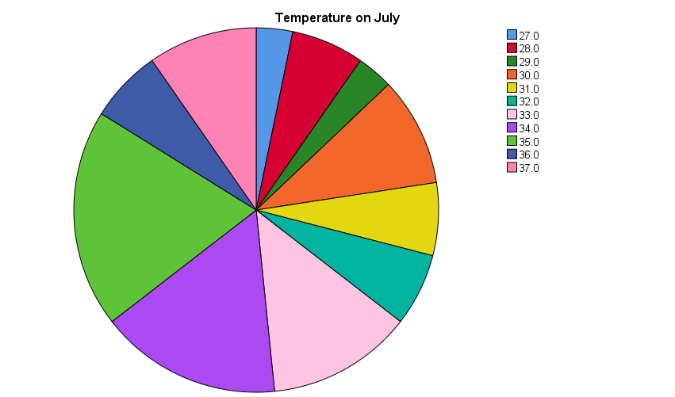

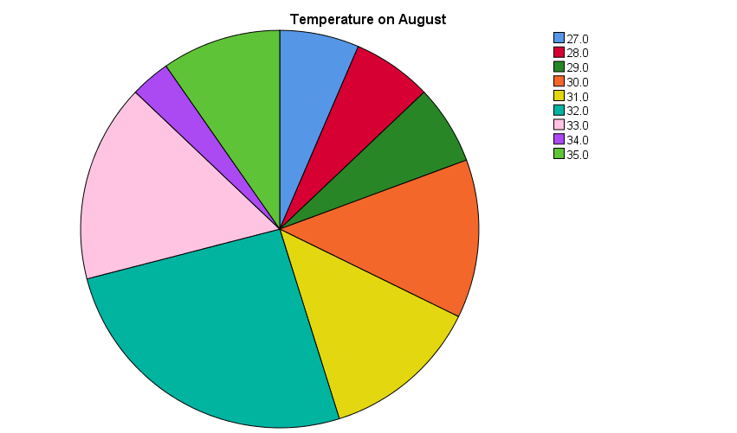

# **Histogram**

FREQUENCIES VARIABLES=January February March April May June July August

/STATISTICS=STDDEV VARIANCE RANGE MINIMUM MAXIMUM SEMEAN MEAN MEDIAN MODE

/HISTOGRAM NORMAL

/ORDER=ANALYSIS.

|  |  |  |  |  |  |  |
| --- | --- | --- | --- | --- | --- | --- |
| **Statistics** | | | | | | |
|  | | Temperature on January | Temperature on February | Temperature on March | Temperature on April | Temperature on May |
| N | Valid | 31 | 29 | 31 | 30 | 31 |
| Missing | 0 | 2 | 0 | 1 | 0 |
| Mean | | 22.613 | 27.966 | 30.839 | 37.100 | 34.290 |
| Std. Error of Mean | | .5157 | .3158 | .4019 | .2553 | .4977 |
| Median | | 23.000 | 28.000 | 31.000 | 37.000 | 34.000 |
| Mode | | 22.0a | 29.0 | 29.0 | 38.0 | 34.0 |
| Std. Deviation | | 2.8714 | 1.7005 | 2.2375 | 1.3983 | 2.7712 |
| Variance | | 8.245 | 2.892 | 5.006 | 1.955 | 7.680 |
| Range | | 10.0 | 6.0 | 8.0 | 5.0 | 11.0 |
| Minimum | | 17.0 | 25.0 | 26.0 | 35.0 | 28.0 |
| Maximum | | 27.0 | 31.0 | 34.0 | 40.0 | 39.0 |

|  |  |  |  |  |
| --- | --- | --- | --- | --- |
| **Statistics** | | | | |
|  | | Temperature on June | Temperature on July | Temperature on August |
| N | Valid | 30 | 31 | 31 |
| Missing | 1 | 0 | 0 |
| Mean | | 32.733 | 33.000 | 31.355 |
| Std. Error of Mean | | .4340 | .5016 | .3923 |
| Median | | 33.500 | 34.000 | 32.000 |
| Mode | | 34.0 | 35.0 | 32.0 |
| Std. Deviation | | 2.3771 | 2.7928 | 2.1840 |
| Variance | | 5.651 | 7.800 | 4.770 |
| Range | | 10.0 | 10.0 | 8.0 |
| Minimum | | 26.0 | 27.0 | 27.0 |
| Maximum | | 36.0 | 37.0 | 35.0 |

|  |
| --- |
| a. Multiple modes exist. The smallest value is shown |

**Frequency Table**

|  |  |  |  |  |  |
| --- | --- | --- | --- | --- | --- |
| **Temperature on January** | | | | | |
|  | | Frequency | Percent | Valid Percent | Cumulative Percent |
| Valid | 17.0 | 2 | 6.5 | 6.5 | 6.5 |
| 18.0 | 4 | 12.9 | 12.9 | 19.4 |
| 21.0 | 1 | 3.2 | 3.2 | 22.6 |
| 22.0 | 6 | 19.4 | 19.4 | 41.9 |
| 23.0 | 5 | 16.1 | 16.1 | 58.1 |
| 24.0 | 3 | 9.7 | 9.7 | 67.7 |
| 25.0 | 6 | 19.4 | 19.4 | 87.1 |
| 26.0 | 3 | 9.7 | 9.7 | 96.8 |
| 27.0 | 1 | 3.2 | 3.2 | 100.0 |
| Total | 31 | 100.0 | 100.0 |  |

|  |  |  |  |  |  |
| --- | --- | --- | --- | --- | --- |
| **Temperature on February** | | | | | |
|  | | Frequency | Percent | Valid Percent | Cumulative Percent |
| Valid | 25.0 | 4 | 12.9 | 13.8 | 13.8 |
| 26.0 | 2 | 6.5 | 6.9 | 20.7 |
| 27.0 | 4 | 12.9 | 13.8 | 34.5 |
| 28.0 | 6 | 19.4 | 20.7 | 55.2 |
| 29.0 | 8 | 25.8 | 27.6 | 82.8 |
| 30.0 | 4 | 12.9 | 13.8 | 96.6 |
| 31.0 | 1 | 3.2 | 3.4 | 100.0 |
| Total | 29 | 93.5 | 100.0 |  |
| Missing | System | 2 | 6.5 |  |  |
| Total | | 31 | 100.0 |  |  |

|  |  |  |  |  |  |
| --- | --- | --- | --- | --- | --- |
| **Temperature on March** | | | | | |
|  | | Frequency | Percent | Valid Percent | Cumulative Percent |
| Valid | 26.0 | 2 | 6.5 | 6.5 | 6.5 |
| 27.0 | 1 | 3.2 | 3.2 | 9.7 |
| 29.0 | 6 | 19.4 | 19.4 | 29.0 |
| 30.0 | 4 | 12.9 | 12.9 | 41.9 |
| 31.0 | 5 | 16.1 | 16.1 | 58.1 |
| 32.0 | 5 | 16.1 | 16.1 | 74.2 |
| 33.0 | 4 | 12.9 | 12.9 | 87.1 |
| 34.0 | 4 | 12.9 | 12.9 | 100.0 |
| Total | 31 | 100.0 | 100.0 |  |

|  |  |  |  |  |  |
| --- | --- | --- | --- | --- | --- |
| **Temperature on April** | | | | | |
|  | | Frequency | Percent | Valid Percent | Cumulative Percent |
| Valid | 35.0 | 5 | 16.1 | 16.7 | 16.7 |
| 36.0 | 6 | 19.4 | 20.0 | 36.7 |
| 37.0 | 5 | 16.1 | 16.7 | 53.3 |
| 38.0 | 10 | 32.3 | 33.3 | 86.7 |
| 39.0 | 3 | 9.7 | 10.0 | 96.7 |
| 40.0 | 1 | 3.2 | 3.3 | 100.0 |
| Total | 30 | 96.8 | 100.0 |  |
| Missing | System | 1 | 3.2 |  |  |
| Total | | 31 | 100.0 |  |  |

|  |  |  |  |  |  |
| --- | --- | --- | --- | --- | --- |
| **Temperature on May** | | | | | |
|  | | Frequency | Percent | Valid Percent | Cumulative Percent |
| Valid | 28.0 | 1 | 3.2 | 3.2 | 3.2 |
| 30.0 | 3 | 9.7 | 9.7 | 12.9 |
| 31.0 | 1 | 3.2 | 3.2 | 16.1 |
| 32.0 | 3 | 9.7 | 9.7 | 25.8 |
| 33.0 | 2 | 6.5 | 6.5 | 32.3 |
| 34.0 | 7 | 22.6 | 22.6 | 54.8 |
| 35.0 | 3 | 9.7 | 9.7 | 64.5 |
| 36.0 | 4 | 12.9 | 12.9 | 77.4 |
| 37.0 | 2 | 6.5 | 6.5 | 83.9 |
| 38.0 | 4 | 12.9 | 12.9 | 96.8 |
| 39.0 | 1 | 3.2 | 3.2 | 100.0 |
| Total | 31 | 100.0 | 100.0 |  |

|  |  |  |  |  |  |
| --- | --- | --- | --- | --- | --- |
| **Temperature on June** | | | | | |
|  | | Frequency | Percent | Valid Percent | Cumulative Percent |
| Valid | 26.0 | 1 | 3.2 | 3.3 | 3.3 |
| 29.0 | 1 | 3.2 | 3.3 | 6.7 |
| 30.0 | 4 | 12.9 | 13.3 | 20.0 |
| 31.0 | 3 | 9.7 | 10.0 | 30.0 |
| 32.0 | 4 | 12.9 | 13.3 | 43.3 |
| 33.0 | 2 | 6.5 | 6.7 | 50.0 |
| 34.0 | 7 | 22.6 | 23.3 | 73.3 |
| 35.0 | 6 | 19.4 | 20.0 | 93.3 |
| 36.0 | 2 | 6.5 | 6.7 | 100.0 |
| Total | 30 | 96.8 | 100.0 |  |
| Missing | System | 1 | 3.2 |  |  |
| Total | | 31 | 100.0 |  |  |

|  |  |  |  |  |  |
| --- | --- | --- | --- | --- | --- |
| **Temperature on July** | | | | | |
|  | | Frequency | Percent | Valid Percent | Cumulative Percent |
| Valid | 27.0 | 1 | 3.2 | 3.2 | 3.2 |
| 28.0 | 2 | 6.5 | 6.5 | 9.7 |
| 29.0 | 1 | 3.2 | 3.2 | 12.9 |
| 30.0 | 3 | 9.7 | 9.7 | 22.6 |
| 31.0 | 2 | 6.5 | 6.5 | 29.0 |
| 32.0 | 2 | 6.5 | 6.5 | 35.5 |
| 33.0 | 4 | 12.9 | 12.9 | 48.4 |
| 34.0 | 5 | 16.1 | 16.1 | 64.5 |
| 35.0 | 6 | 19.4 | 19.4 | 83.9 |
| 36.0 | 2 | 6.5 | 6.5 | 90.3 |
| 37.0 | 3 | 9.7 | 9.7 | 100.0 |
| Total | 31 | 100.0 | 100.0 |  |

|  |  |  |  |  |  |
| --- | --- | --- | --- | --- | --- |
| **Temperature on August** | | | | | |
|  | | | | | |
|  | | Frequency | Percent | Valid Percent | Cumulative Percent |
| Valid | 27.0 | 2 | 6.5 | 6.5 | 6.5 |
| 28.0 | 2 | 6.5 | 6.5 | 12.9 |
| 29.0 | 2 | 6.5 | 6.5 | 19.4 |
| 30.0 | 4 | 12.9 | 12.9 | 32.3 |
| 31.0 | 4 | 12.9 | 12.9 | 45.2 |
| 32.0 | 8 | 25.8 | 25.8 | 71.0 |
| 33.0 | 5 | 16.1 | 16.1 | 87.1 |
| 34.0 | 1 | 3.2 | 3.2 | 90.3 |
| 35.0 | 3 | 9.7 | 9.7 | 100.0 |
| Total | 31 | 100.0 | 100.0 |  |

**Histogram**

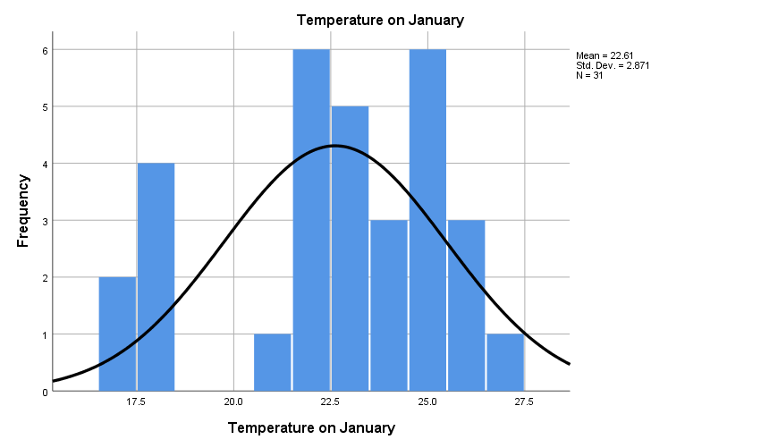

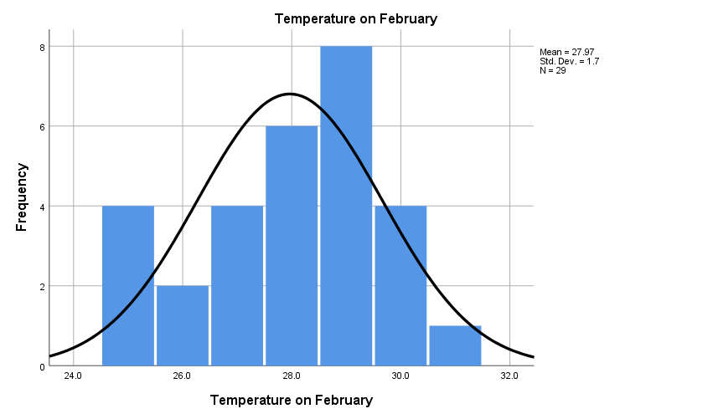

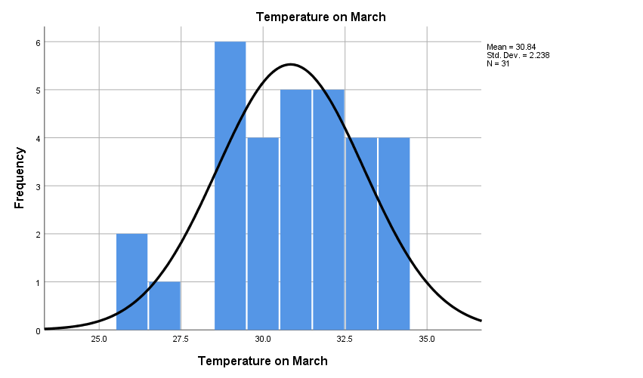

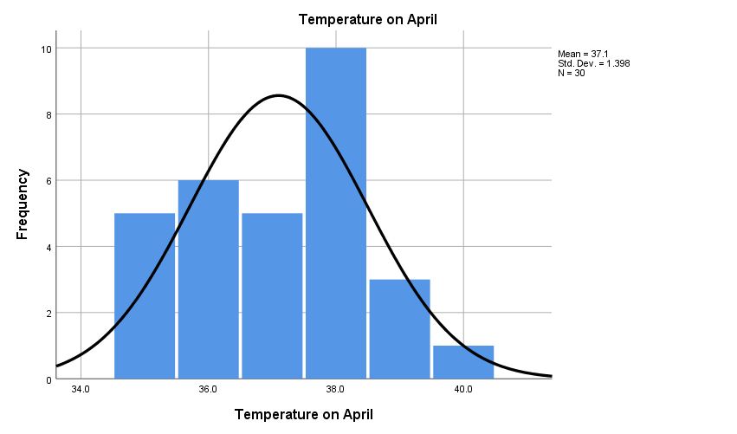

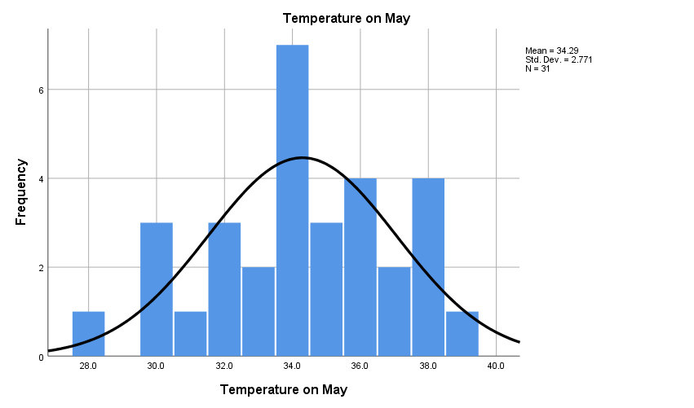

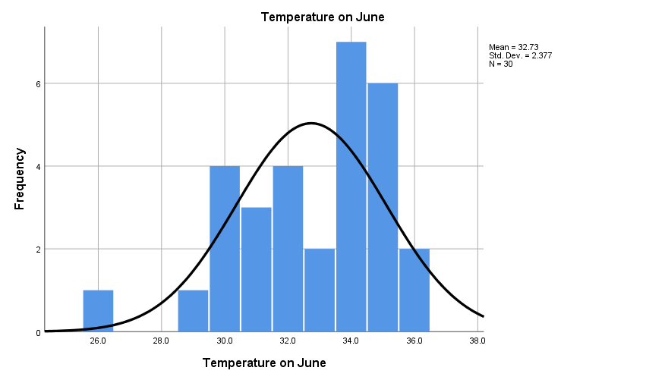

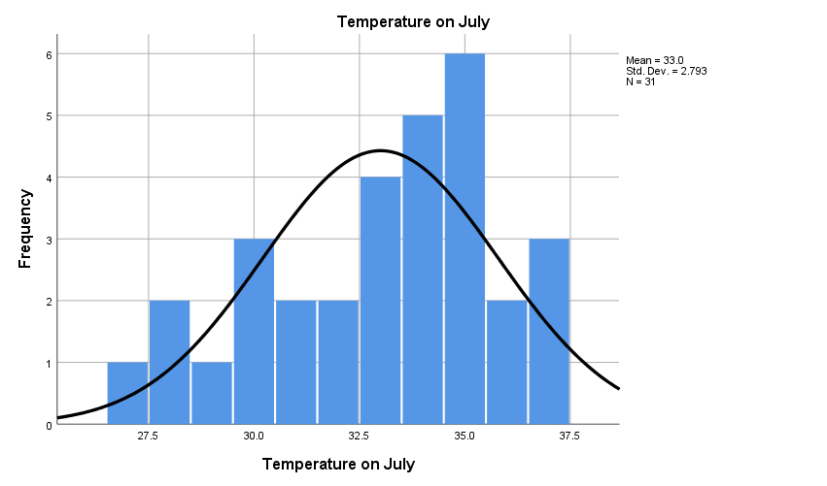

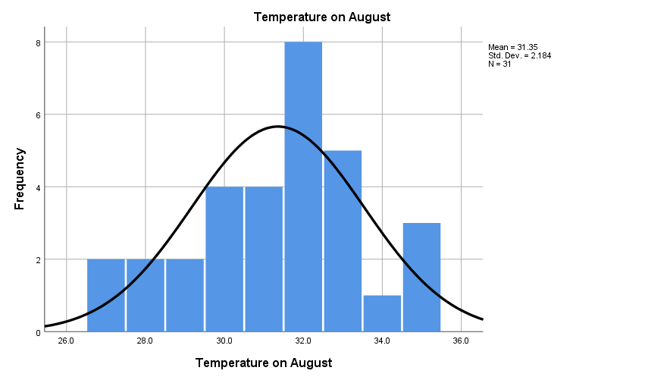

**Correlation**

CORRELATIONS

/VARIABLES=January February March April May June July August

/PRINT=TWOTAIL NOSIG

/MISSING=PAIRWISE.

|  |  |  |  |  |
| --- | --- | --- | --- | --- |
| **Correlations** | | | | |
|  | | Temperature on January | Temperature on February | Temperature on March |
| Temperature on January | Pearson Correlation | 1 | -.332 | -.109 |
| Sig. (2-tailed) |  | .078 | .561 |
| N | 31 | 29 | 31 |
| Temperature on February | Pearson Correlation | -.332 | 1 | .262 |
| Sig. (2-tailed) | .078 |  | .170 |
| N | 29 | 29 | 29 |
| Temperature on March | Pearson Correlation | -.109 | .262 | 1 |
| Sig. (2-tailed) | .561 | .170 |  |
| N | 31 | 29 | 31 |
| Temperature on April | Pearson Correlation | .169 | .343 | .181 |
| Sig. (2-tailed) | .373 | .069 | .339 |
| N | 30 | 29 | 30 |
| Temperature on May | Pearson Correlation | -.249 | .003 | .051 |
| Sig. (2-tailed) | .176 | .988 | .786 |
| N | 31 | 29 | 31 |
| Temperature on June | Pearson Correlation | -.188 | -.082 | -.017 |
| Sig. (2-tailed) | .319 | .674 | .930 |
| N | 30 | 29 | 30 |
| Temperature on July | Pearson Correlation | .054 | .382* | -.133 |
| Sig. (2-tailed) | .773 | .041 | .475 |
| N | 31 | 29 | 31 |
| Temperature on August | Pearson Correlation | .055 | .031 | .230 |
| Sig. (2-tailed) | .771 | .872 | .212 |
| N | 31 | 29 | 31 |

|  |  |  |  |  |
| --- | --- | --- | --- | --- |
| **Correlations** | | | | |
|  | | Temperature on April | Temperature on May | Temperature on June |
| Temperature on January | Pearson Correlation | .169 | -.249 | -.188 |
| Sig. (2-tailed) | .373 | .176 | .319 |
| N | 30 | 31 | 30 |
| Temperature on February | Pearson Correlation | .343 | .003 | -.082 |
| Sig. (2-tailed) | .069 | .988 | .674 |
| N | 29 | 29 | 29 |
| Temperature on March | Pearson Correlation | .181 | .051 | -.017 |
| Sig. (2-tailed) | .339 | .786 | .930 |
| N | 30 | 31 | 30 |
| Temperature on April | Pearson Correlation | 1 | .141 | -.189 |
| Sig. (2-tailed) |  | .458 | .318 |
| N | 30 | 30 | 30 |
| Temperature on May | Pearson Correlation | .141 | 1 | -.058 |
| Sig. (2-tailed) | .458 |  | .762 |
| N | 30 | 31 | 30 |
| Temperature on June | Pearson Correlation | -.189 | -.058 | 1 |
| Sig. (2-tailed) | .318 | .762 |  |
| N | 30 | 30 | 30 |
| Temperature on July | Pearson Correlation | .317 | -.362* | -.147 |
| Sig. (2-tailed) | .088 | .046 | .438 |
| N | 30 | 31 | 30 |
| Temperature on August | Pearson Correlation | .035 | -.249 | .339 |
| Sig. (2-tailed) | .855 | .177 | .067 |
| N | 30 | 31 | 30 |

|  |  |  |  |
| --- | --- | --- | --- |
| **Correlations** | | | |
|  | | Temperature on July | Temperature on August |
| Temperature on January | Pearson Correlation | .054 | .055 |
| Sig. (2-tailed) | .773 | .771 |
| N | 31 | 31 |
| Temperature on February | Pearson Correlation | .382* | .031 |
| Sig. (2-tailed) | .041 | .872 |
| N | 29 | 29 |
| Temperature on March | Pearson Correlation | -.133 | .230 |
| Sig. (2-tailed) | .475 | .212 |
| N | 31 | 31 |
| Temperature on April | Pearson Correlation | .317 | .035 |
| Sig. (2-tailed) | .088 | .855 |
| N | 30 | 30 |
| Temperature on May | Pearson Correlation | -.362* | -.249 |
| Sig. (2-tailed) | .046 | .177 |
| N | 31 | 31 |
| Temperature on June | Pearson Correlation | -.147 | .339 |
| Sig. (2-tailed) | .438 | .067 |
| N | 30 | 30 |
| Temperature on July | Pearson Correlation | 1 | .005 |
| Sig. (2-tailed) |  | .977 |
| N | 31 | 31 |
| Temperature on August | Pearson Correlation | .005 | 1 |
| Sig. (2-tailed) | .977 |  |
| N | 31 | 31 |

|  |
| --- |
| *. Correlation is significant at the 0.05 level (2-tailed). |

# **Variance**

DESCRIPTIVES VARIABLES=January February March April May June July August

/STATISTICS=MEAN STDDEV VARIANCE RANGE MIN MAX.

|  |  |  |  |  |  |  |
| --- | --- | --- | --- | --- | --- | --- |
| **Descriptive Statistics** | | | | | | |
|  | N | Range | Minimum | Maximum | Mean | Std. Deviation |
| Temperature on January | 31 | 10.0 | 17.0 | 27.0 | 22.613 | 2.8714 |
| Temperature on February | 29 | 6.0 | 25.0 | 31.0 | 27.966 | 1.7005 |
| Temperature on March | 31 | 8.0 | 26.0 | 34.0 | 30.839 | 2.2375 |
| Temperature on April | 30 | 5.0 | 35.0 | 40.0 | 37.100 | 1.3983 |
| Temperature on May | 31 | 11.0 | 28.0 | 39.0 | 34.290 | 2.7712 |
| Temperature on June | 30 | 10.0 | 26.0 | 36.0 | 32.733 | 2.3771 |
| Temperature on July | 31 | 10.0 | 27.0 | 37.0 | 33.000 | 2.7928 |
| Temperature on August | 31 | 8.0 | 27.0 | 35.0 | 31.355 | 2.1840 |
| Valid N (listwise) | 29 |  |  |  |  |  |

|  |  |
| --- | --- |
| **Descriptive Statistics** | |
|  | Variance |
| Temperature on January | 8.245 |
| Temperature on February | 2.892 |
| Temperature on March | 5.006 |
| Temperature on April | 1.955 |
| Temperature on May | 7.680 |
| Temperature on June | 5.651 |
| Temperature on July | 7.800 |
| Temperature on August | 4.770 |
| Valid N (listwise) |  |

# **Skewness**

DESCRIPTIVES VARIABLES=January February March April May June July August

/STATISTICS=MEAN STDDEV VARIANCE RANGE MIN MAX SKEWNESS.

|  |  |  |  |  |  |  |
| --- | --- | --- | --- | --- | --- | --- |
| **Descriptive Statistics** | | | | | | |
|  | N | Range | Minimum | Maximum | Mean | Std. Deviation |
| Statistic | Statistic | Statistic | Statistic | Statistic | Statistic |
| Temperature on January | 31 | 10.0 | 17.0 | 27.0 | 22.613 | 2.8714 |
| Temperature on February | 29 | 6.0 | 25.0 | 31.0 | 27.966 | 1.7005 |
| Temperature on March | 31 | 8.0 | 26.0 | 34.0 | 30.839 | 2.2375 |
| Temperature on April | 30 | 5.0 | 35.0 | 40.0 | 37.100 | 1.3983 |
| Temperature on May | 31 | 11.0 | 28.0 | 39.0 | 34.290 | 2.7712 |
| Temperature on June | 30 | 10.0 | 26.0 | 36.0 | 32.733 | 2.3771 |
| Temperature on July | 31 | 10.0 | 27.0 | 37.0 | 33.000 | 2.7928 |
| Temperature on August | 31 | 8.0 | 27.0 | 35.0 | 31.355 | 2.1840 |
| Valid N (listwise) | 29 |  |  |  |  |  |

|  |  |  |  |
| --- | --- | --- | --- |
| **Descriptive Statistics** | | | |
|  | Variance | Skewness | |
| Statistic | Statistic | Std. Error |
| Temperature on January | 8.245 | -.694 | .421 |
| Temperature on February | 2.892 | -.411 | .434 |
| Temperature on March | 5.006 | -.471 | .421 |
| Temperature on April | 1.955 | -.028 | .427 |
| Temperature on May | 7.680 | -.322 | .421 |
| Temperature on June | 5.651 | -.832 | .427 |
| Temperature on July | 7.800 | -.540 | .421 |
| Temperature on August | 4.770 | -.303 | .421 |
| Valid N (listwise) |  |  |  |

**Conclusion:**

The analysis of temperature data from January to August reveals clear trends in seasonal variation. The bar graph highlights the increase in temperature as we move toward the warmer months, while the histogram confirms the concentration of temperatures within specific ranges. The pie chart offers a visual summary of temperature distributions, and the correlation analysis shows a significant relationship between dates and temperature progression. These visual tools collectively provide a comprehensive overview, aiding in more informed decision-making for industries dependent on climate and offering insights into how temperatures change throughout the year.

**Reference:**

[**Weather in January 2024 in Dhaka, Bangladesh (timeanddate.com)**](https://www.timeanddate.com/weather/bangladesh/dhaka/historic?month=1&year=2024)